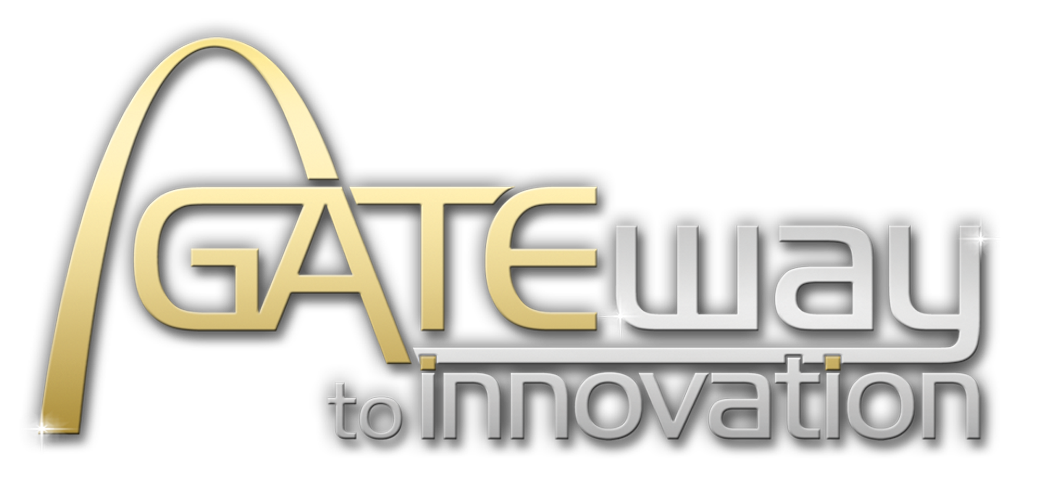

Media Advisory

Gateway to Innovation Surpasses $2 Million in Donations for
IT Education, Non-profit Technology and the St. Louis Tech Eco-system

Region’s Largest IT Conference Will Announce 2019 Community Giveback Recipients
At 8:30 am Monday September 9, 2019

St. Louis, MO – Gateway to Innovation (G2I), the annual one-day conference for St. Louis area technology professionals that returns conference proceeds to the community, will exceed a major milestone in technology related contributions in 2019. G2I community giveback will total $2,009,967 dating to the first conference in 2006. G2I will present contributions to the remaining 2019 recipients during a special event hosted at T-REX, 911 Washington Avenue in downtown St. Louis Monday September 9, 2019 at 8:30 am
Each year G2I donates 100 percent of net proceeds from its increasingly popular annual conference. The 2019 conference, attended by 1,500 regional Information Technology (IT) professionals in downtown St. Louis in late April, generated $330,016 in community giveback.
- WHO: Gateway to Innovation

- WHAT: Special Awards Ceremony

- WHERE: T-REX, 911 Washington Avenue, 5th floor – Downtown St. Louis, MO

- WHEN: 8:30 am --- Monday September 9, 2019

- WHY: Recognize the economic importance of technology; provide financial support for innovative technology initiatives through proceeds generated by Gateway to Innovation.

The funds are presented in the form of scholarships, endowments for college/university technology programs, grants to organizations that drive technology-related economic development in the region, and financial contributions for schools or non-profit organizations that demonstrate technology-related challenges.

Initial 2019 contributions were presented at the April conference for scholarships to six St. Louis area high school students pursuing a technology degree at a local university, Cardinals Care, and Boys Hope Girls Hope of St. Louis.
At the special ceremony, G2I will also highlight the tremendous impact technology has on the St. Louis economy.

About Gateway to Innovation: Gateway to Innovation is the premier annual collaboration and networking event for IT Professionals in the St. Louis region. Gateway to Innovation inspires innovation through premier educational opportunities led by the industry’s top leaders, provides an opportunity to share best practices and fosters collaboration with colleagues who face challenges and opportunities in our fast-paced industry. Since the first event in 2006, Gateway to Innovation has donated $2,009,967 for IT scholarships and for technology-related grants to St. Louis area educational and non-profit organizations. More information can be found at www.g2iconference.com or by contacting Kristin Tucker at 314-276-7600.

